Hardware Design Spec

(HDS)
for
DAU A308 Pro

Prepared for:
Schill Reglerteknik AB

Prepared by:
NOW Electronics AB
REVISION SUMMARY

Rev | Issued By | Date | Description
A | NJW/NOW | 0701xx | First released version

1. SCOPE 3
1.1. Identification 3
1.2. Introduction 3
1.3. REFERENCED DOCUMENTS 4
2. DEFINITIONS, ACRONYMS AND ABBREVIATIONS 5
3. DESIGN DESCRIPTION 6
3.1. DAU Overview 6
3.1.1. Overview Requirements 7
3.2. Interfaces 7
3.2.1. Sensor interface 8
3.2.2. Gyro interface (synchronous and RS-422) 8
3.2.3. USB Interface 8
3.2.4. Power interface 9
3.2.5. Test output from D/A 9
3.3. Hardware Design Description 9
3.3.1. Power 9
3.3.2. Amplifier 10
3.3.3. LP-filter 11
3.3.4. MUX 11
3.3.5. AD 11
3.3.6. DA 12
3.3.7. Temp 13
3.3.8. S/D 13
3.3.9. Synchronous 13
3.3.10. Logic 14
3.3.11. USB 15
3.4. Function Description 16
3.4.1. Sample mode 17
3.4.2. Continues mode 17
4. DETAILED DESIGN 18
4.1. USB interface 18
4.1.1. Writing registers 18
4.1.2. Receive frame format 18
4.2. FPGA 20
4.2.1. Block-diagram 20
4.2.2. Functional description 20
4.2.3. Registers 23
4.3. USB mapping 26
4.4. Mapped register 26
4.5. PCB 27
4.5.1. Interface PCB 27
4.5.2. Main PCB 28

SCOPE

Identification
This document describes how the DAU unit shall be designed. This document is built on the Requirements Specification ”ReqSpec_DAU_A308_A303.doc”. This document is also written in the spirit of NOW Quality standard [Ref 1]. Design rules are specified by standard from document “Konstruktionshandbok” [Ref 2].

Introduction
DAU is a unit for collecting data from sensors and gyro in the Aligner system. All data are then send to a computer over a USB connection. The DAU unit shall be made in two versions, one complete version for the Aligner 308 system and on slim version in the Aligner 303 system.

Figure 1 System diagram Aligner 308
2-axle
roll/pitch
sensor
2-axle
roll/pitch
sensor
2-axle
roll/pitch
sensor
2-axle
roll/pitch
sensor
2-axle
roll/pitch
sensor
2-axle
roll/pitch
sensor
2-axle
roll/pitch
sensor
Gyro

Gyro

DAU

USB
115-230 Volt AC
50-60 Hz
Test Voltage Output

Computer (PC)

REFERENCED DOCUMENTS
No. | Identification | Name or Description
Ref 1 | 96QD0129 | Kvalitetsstyrning hos NOW Electronics AB
Ref 2 | 96QD0023 | Konstruktionshandbok (av NOW Electronics)

DEFINITIONS, ACRONYMS AND ABBREVIATIONS
DEFINITION | EXPLANATION
TBD | To Be Done (Used in draft versions).

ACRONYM or  ABBREVIATION | EXPLANATION
HDD | Hardware Design Document
N/A | Not Applicable
PC | Personal Computer

DESIGN DESCRIPTION

DAU Overview
Figure 2 Function block diagram Aligner 308

MUX
Inst.
Amplifier
LP
Inst.
Amplifier
LP
Inst.
Amplifier
LP
Inst.
Amplifier
LP
Inst.
Amplifier
LP
Logic
(FPGA)
Inst.
Amplifier
LP
Inst.
Amplifier
LP
A/D
Seven
sensors
whit
roll
and
pitch

Inst.
Amplifier
LP
Inst.
Amplifier
LP
Inst.
Amplifier
LP
Inst.
Amplifier
LP
Inst.
Amplifier
LP
Inst.
Amplifier
LP

Inst.
Amplifier
LP

USB
PC
D/A

Seven
sensors
temp

MUX

Temp

Synchronous
RS-422
Gyro 1

Gyro 2

S/D
Gyro 1
Gyro 2

Overview Requirements
Temperature Operating: +5 ºC - +55 ºC
Non-operating: -20 ºC - +60 ºC
Relative Humidity Operating: 95 %, non-condensing
Non-operating: 95 %, non-condensing
Shock Oper & non-oper: 15g, 11 ms
Vibration Oper & non-oper: 1 g, 5-500 Hz

Interfaces
The 308 system DAU have flowing interface:
- Seven 308 sensor with roll, pitch and temperature.
- Two gyros interface with a synchronous and RS-422 interface.
- One USB interface connected to a PC.

Sensor interface
Connector: D38999/24WB35SN
Figure 3 Connector  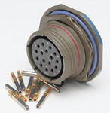 |  | Table 1 Sensor connector
  Pin | Designation | Pin | Designation
  1 | + 15 V | 8 | Roll
  2 | - 15 V | 9 | Temperature
  3 | GND | 10 | ---
  4 | Roll return (and Pitch ret) | 11 | ---
  5 | Pitch | 12 | ---
  6 | Pitch return (n.u.) | 13 | ---
  7 | ---

Gyro interface (synchronous and RS-422)
Connector: D38999/24WB35PN
Figure 4 Connector  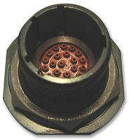 |  | Table 2 Sensor connector
  Pin | Designation | Pin | Designation
  1 | R1 | 8 | S1 pitch
  2 | R2 | 9 | S2 pitch
  3 | S1 roll | 10 | S3 pitch
  4 | S2 roll | 11 | RS-422 Data+
  5 | S3 roll | 12 | RS-422 Data-
  6 | RS-422 Clk+ | 13 | Digital GND
  7 | RS-422 Clk-

USB Interface
Connector: AMP 0-0292304-1
Figure 5 USB Connector  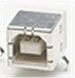 |  | Table 3 USB connector
  Pin | Designation | Pin | Designation
  1 | +5 V (Input) | 3 | Data +
  2 | Data - | 4 | GND
Durability – 1500 cycles.

Power interface
Connector: Bulgin BZV15/Z0000/11, fused power inlet modules polysnap.

Figure 6 Power connector
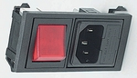

Test output from D/A
Connector: Deltron, type 571
Figure 7 Connector  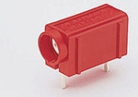 |  | Table 4 USB connector
  Pin | Designation
  RED | Analog output from D/A
  BLACK | GND

Hardware Design Description

Power

General
The power shall be connect to power interface in 3.2.4. The VAC power shall then be convert to +15 Volt, + 5 Volt and – 5 Volt DC.

Operation
The power connecter shall have a build-in 400 mA fuse. On the PCB a TML30515 module shall generate all DC power. PCB area around this module shall be careful used (split up power planes, filter and so on). Output: 5 V – 3A and ±15 V – 0.5 A.

Figure 8 TML30515 power module
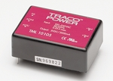

Requirements
Voltage: 85 - 264 VAC (auto range)
Frequency: 47 - 63 Hz
Power drop out tolerance: 100 % for 10 ms
+5 Volt current /TBD/ A
+15 Volt current /TBD/ A
–15 Volt current /TBD/ A

Amplifier

General
Amplifiers are used on all sensor interfaces (both for the 303 and 308 system).

Operation
The INA101KU device (SOIC-16) shall be used for this function. The device shall only buffer and amplifier the signal from the sensor. All calibration shall be made in the PC software.

Figure 9 Block diagram for the INA101 device
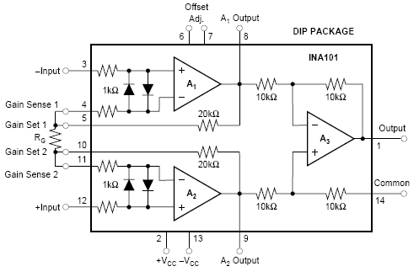

Requirements
Equal or better then amplifier in old hardware (INA101).
Data from INA101 Datasheet:
Noise: 13nV/√Hz

LP-filter

General
The amplified signal from the sensors shall be low pass filtered on the card.

Operation
The low pass filter shall be build with a low noise OP. The LTC1057IS#PBF device (SOIC-8) from Linear Technology shall be used for this function.

Requirements
Equal or better then OP in old hardware (LT1057).
LP frequency: /TBD/ Hz

MUX

General
Sensor-, temp- and internal measure signals shall be multiplex to one output.

Operation
14 sensors, 7 temp signals (from the sensors), 1 temp (from PCB), D/A output and all DC powers shall MUX to one output. Two DG406DYZ devices (SOIC-28) shall be used for this function.

Requirements
Equal or better then MUX in old hardware (DG406).

AD

General
The AD converts an analog signal to a 16 bit digital values.

Operation
The AD7674AST or AD7678AST device (LQFP-48) shall be used for this function. The input might go throw an OP (same as in 3.3.3) to adjust voltage swing and impedance.

Figure 10 Functional block diagram for AD7678
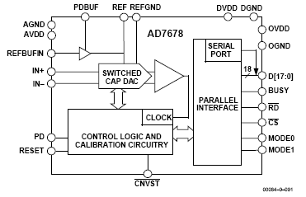

Requirements
Equal or better then AD in old hardware (ADC700).
Sampling rate min : 16 KHz.

DA

General
The DA device is for calibration use.

Operation
The AD669BR device shall be used for this function. Calibration is made with two potentiometers.

Requirements
Equal or better then DA in old hardware (AD669).

Temp

General
The PCB temperature shall me measured.

Operation
The /TBD/ device shall be used for this function.

Requirements
Measured temp rage: -20 ºC - +60 ºC

S/D

General
This device converts gyro data to parallel data.

Operation
The DDC 14620 device shall be used for this function.

Requirements
It shall be compatible with the gyros S/D interface.

Synchronous

General
This device converts RS-422 gyro data to parallel data.

Operation
The Zilog 85230 device shall be used for this function. As a spare solution (if the device is obsolete) a simple RS-422 device shall be placed on the PCB. In this case all logic is done in the logic block.

Figure 11 Functional block diagram for Zilog 85230

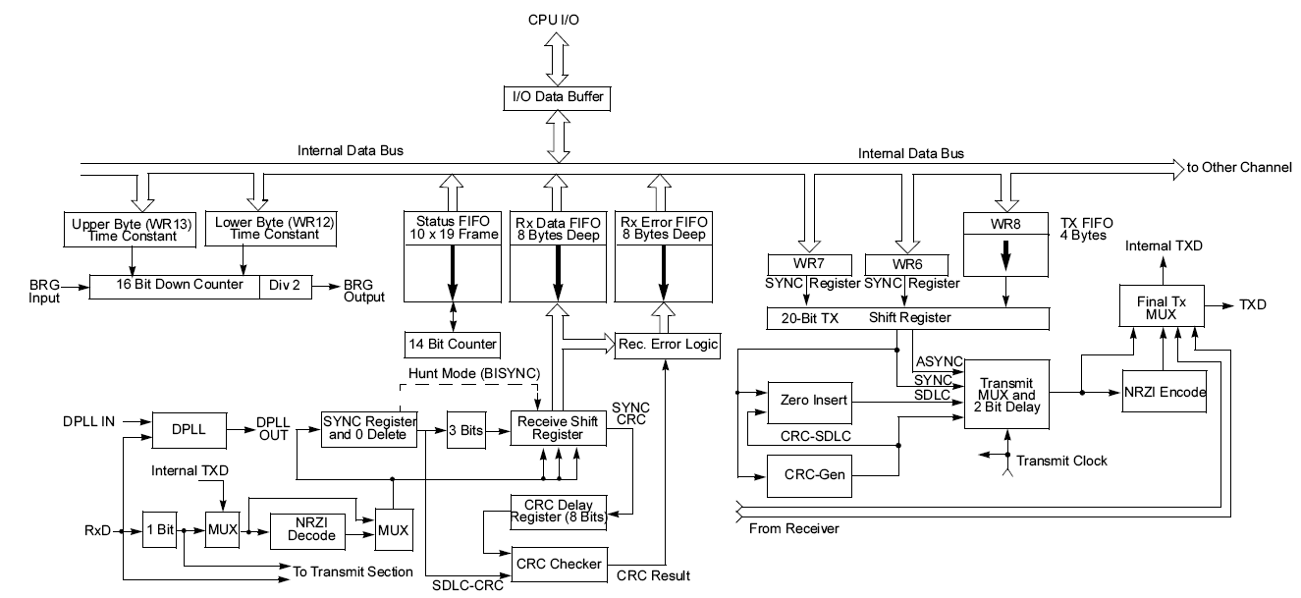

Requirements
It shall be compatible with the gyros RS-422 interface.

Logic

General
This device control all logic on the card.

Operation
The Altera EPF10K30ETC144-3N in a 144-TQFP (102-I/O) shall be used for this function.

Requirements
Table 5 USB connector
Interface | Number of I/O
A/D | ~20 I/O
D/A | ~20 I/O
Synchronous | ~15 I/O
RS-422 | ~10 I/O
USB | ~5 I/O
S/N and Rev ID | ~16 I/O
Total | ~91 I/O

USB

General

Operation
The FT232BM device shall be used for this function. This device convert a RS-232 (from the logic device) to a USB interface.

Figure 12 Functional block diagram for FT232BM
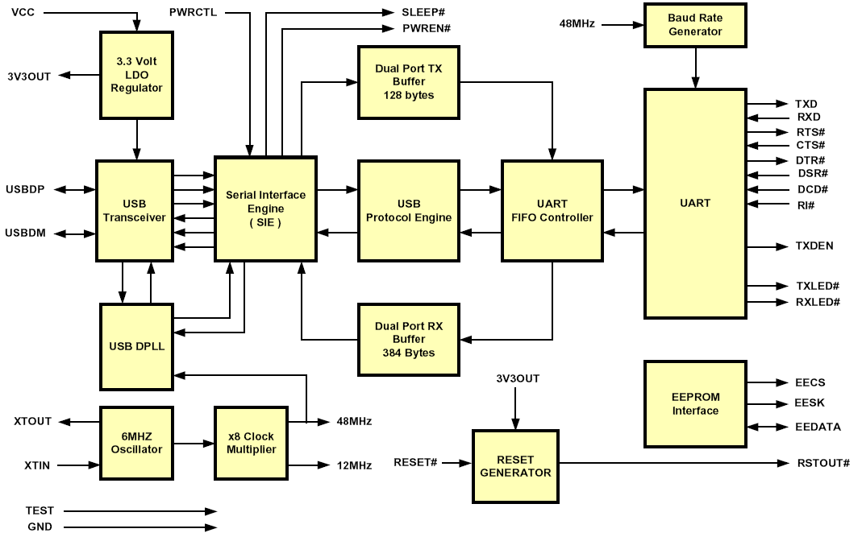

Requirements
The device shall be compatible with USB 1.1.

Function Description
All functions is controlled by the FPGA described in 3.3.10.

Figure 13 Function description for the logic in the FPGA.

Continues USB read and write to the synchronous and
RS-422 block.
All sequence read is started by command from PC

Read all Sensor values,
store result in memory
Sample mode
Mode
1 KHz Sample
Temp and power values,
store result in memory
USB read and write all values form sensors, temp, and last package from synchronous and
RS-422 block
Continues mode
Change mode
Change mode

Sample mode
In sample mode all register values is send every 10 ms over USB. The send data is following:
- Fix header information (S/N and Revision for the card).
- Dynamic header (sequence number) update ever sample.
- Power and temp from sensor and card is update every sample.
- All synchronous are update (last package received is send).
- All RS-422 are update (last package received is send).

Continues mode
In this mode the PC control the unit by sending different commands. The command setup the hardware (devices on the card). All sequence read are started with a command from the PC. On this request all bytes in the last received package is send to the PC.

DETAILED DESIGN

USB interface
The DAU is controlled from a PC over an USB interface. A number of registers in the FPGA can be written and the acquired data are sent up to the PC.

Writing registers
The registers located in the FPGA can be written over USB by writing the command byte C3h followed by all registers.

The registers in the FPGA are defined in section 4.2.3.

Receive frame format
The data sent from the DAU to the PC over USB is encapsulated into frames. The format of the frames are defined in the following table.

Byte | Field | Description
0 | SYNC_BYTE1 | = 0xAA
1 | SYNC_BYTE2 | = 0x55
2 | LENGTH | Length of the PAYLOAD-field
3 | TYPE | Type of frame (defines the type of data in the frame)  1 = ADC-data  2 = Data from HDLC A  3 = Data from HDLC B  4 = Data from UART A  5 = Data from UART B  7 = Registers
4 to N-2 | PAYLOAD | Data (length 0-255 bytes)
N-1 | CRC8 | CRC calculated with polynom x8+x5+x4+1  The CRC is calculated on LENGTH, TYPE and PAYLOAD

De-framing
Do following
- Wait for sync-pattern AAh followed by 55h
- Read length field
- Read frame-type field
- Read the payload (LENGTH numbers of bytes)
- Calculate and check the cheksum. If incorrect, the de-framing is probably out of sync. Waste the two sync-bytes. Goto 1. and find new sync-pattern.

Register-frame
The payload of the register-frames contains all the registers in the FPGA. The following data is transferred. One register-frame is sent after each sample_start (61 Hz).

Byte | Register
0 | CTRL_REG
1 | TEST_BYTE
2 | SCTRL_A
3 | UARTA_CTRL
4 | UARTA_DIV[7..0]
5 | UARTA_DIV[13..8]
6 | SCTRL_B
7 | UARTB_CTRL
8 | UARTB_DIV[7..0]
9 | UARTB_DIV[13..8]
10 | DAC_DATA[7..0]
11 | DAC_DATA[15..8]
12 | SDC
13 | 0
14 | 0
15 | 0

Data-frame
The payload of the data-frames contains the collected data from the synchrodigital converters and from the ADCs. The following data is transferred.
Byte | Data
0 | Bit 7 = HDLC_A_LOST, HDLC-frame lost from receiver A  Bit 6 = HDLC_B_LOST, HDLC-frame lost from receiver B  Bit 5 = ACQ_LOST, Acqusition frame lost due to AFIFO not emptied.  Bit 4 = USB_TXFIFO_HALF, USB transmit-fifo atleast half-full  Bit 3 = SFIFO_A_HALF, Serial fifo A atleast half-full  Bit 2 = SFIFO_B_HALF, HDLC B fifo atleast half-full  Bit 1 = ERR_PAR_A, Uart A parity error  Bit 0 = ERR_PAR_B, Uart B parity error
1 | Status  Bit 7..5 = TempSel (the source of the temperatur value)  Bit 4 = Synchro-digital error
2 | SDC0[7..0] LSB data from syncro-digital converter 0
3 | SDC0[15..8] MSB data from syncro-digital converter 0
4-7 | ::::::::::::::::::
8 | SDC3[7..0] LSB data from syncro-digital converter 3
9 | SDC3[15..8] MSB data from syncro-digital converter 3
10 | Pitch 0, bit 7..0
11 | Pitch 0, bit 15..8
12 | Roll 0, bit 7..0
13 | Roll 0, bit 15..8
14-33 | Pitch, roll 1-5
34 | Pitch 6, bit 7..0
35 | Pitch 6, bit 15..8
36 | Roll 6, bit 7..0
37 | Roll 6, bit 15..8
38 | Temperature, bit 7..0
39 | Temperature, bit 15..8
40 | DAC-voltage, bit 7..0
41 | DAC-voltage, bit 15..8

UART-frame
The data from the UARTs are just encapsulated into the frames as it comes.

HDLC-frame
The HDLC-frame contains one complete HDLC-frame with an added status-byte last. Bit 2..0 in the status-byte defines the number of bits-1 in the last byte (the byte prior to the status-byte). If all bits are valid, this field is 0.

FPGA

Block-diagram
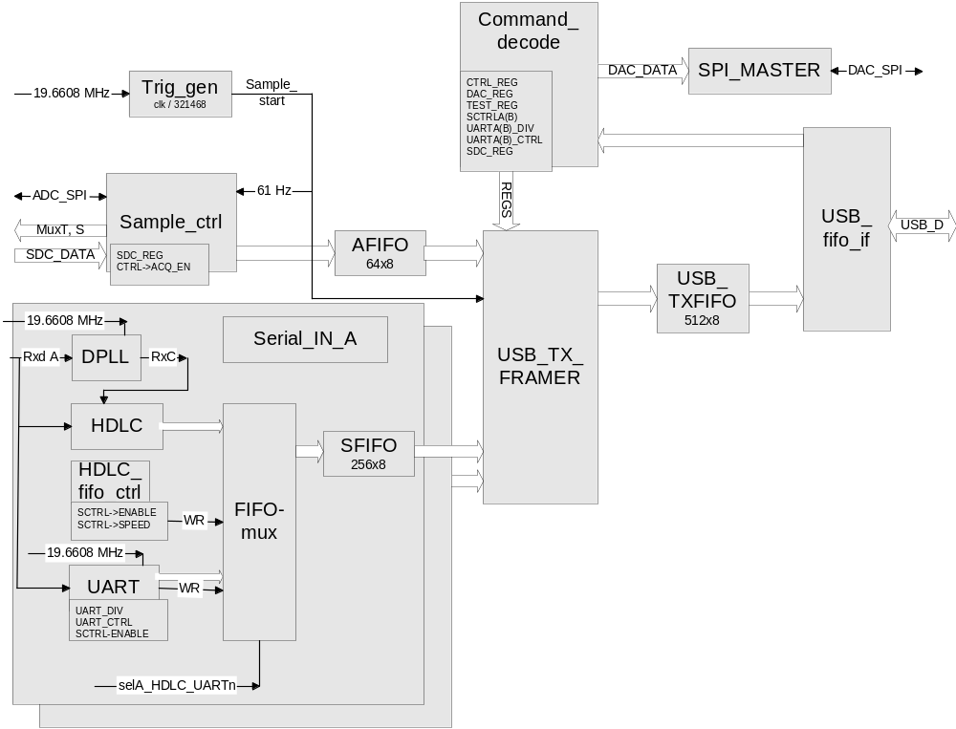

Functional description

USB_FIFO_IF
This is the interface to the USB-controller FT245. The following is done:
- Controls if there are any data to read from FT245. If so, the data is read and transferred to the command-decode block.
- Reads USB_TXFIFO and writes the data to FT245 (if possible).

Command-decode
Decodes command from USB_FIFO_IF.

USB-Tx-Framer
Encapsulates the data from the HDLC-receivers, UARTs, ADCs, SDCs and registers into USB-frames.

After each rising edge of sample_start (61 Hz acquisition trigger) the FPGA-registers are encapsulated into a frame and transferred.

The UART-fifos are read when the fill level of the fifo is over the configured threshhold.

The HDLC-fifos are read when a complete frame is written to the fifo. The complete HDLC-frame is then transferred in one USB-frame.

When a complete acquisition cycle is done, the AFIFO is read and the data is transferred.

Sample-ctrl
Sample-ctrl reads the values of the synchro-digital converters and controls the muxes and ADCs.
The acqusition cycle starts on the rising edge of sample_start if acq_en=1 and fifo_ef=1. If fifo_ef=0 then the acqusition cycle is not started end the error-signal acq_lost is set.
Below is a simplified state-diagram of the sample-ctrl shown.
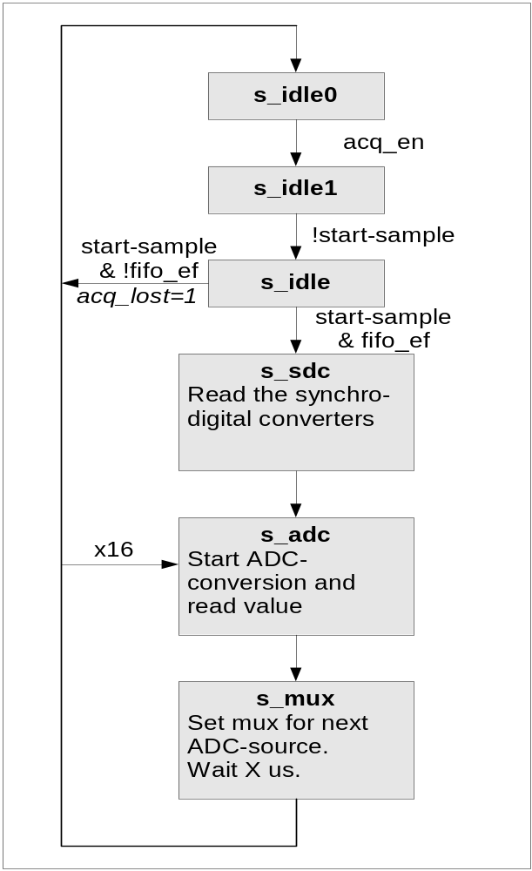

HDLC
The serial HDLC datastream first enters a DPLL. The DPLL locks the sample-clock to the data-bits.

The following things are done:
- The receivers detects the start and stop of the HDLC-frames and writes the frames into a fifo.
- Removes sync-bits in the datastream.
- Doesn’t check CRC

The bit-rate can be configured to 76.8, 153.6, 307.2 or 614.4 kbits/s. Same configuration for both receivers.

UART
There are two UARTs. The data input to the UARTs are the same as for the HDLC-reveivers.

The baud-rate, number of data-bits, parity (on/off, even/odd) can be configured. Both UARTs use the same configuration.

Registers
The FPGA holds the following registers:
Offset | Name | Reset-value | Description
0 | CTRL_REG |  | Control-bits
1 | TEST_BYTE |  | Test
2 | SCTRL_A |  | Serial A control
3 | UARTA_CTRL |  | Control bits for UART A
4 | UARTA_DIV[13..8] |  | Division factor for UART A baud-rate
5 | UARTA_DIV[7..0] |  | Division factor for UART A baud-rate
6 | SCTRL_B |  | Serial B control
7 | UARTB_CTRL |  | Control bits for UART B
8 | UARTB_DIV[13..8] |  | Division factor for UART B baud-rate
9 | UARTB_DIV[7..0] |  | Division factor for UART B baud-rate
10 | DAC_DATA[15..8] |  | DAC
11 | DAC_DATA[7..0] |  | DAC
12 | SDC |  | Synchro digital resolution
13 | BOARD_SN |  | Bygelfält J10001. Kan endast läsas. Uppdateras vid skrivning av registret.
14
15

CTRL_REG
Bit | Name | Reset-value | Description
7 | USB_TX_ON | 0 | När denna bit är =1 skickar A308 ut data på USB.
6 | ADC_TEST_DATA | 0
5..4 | SAMPLE_SPEED | 00b | 00b => 61 Hz acqusition cycle (default)  01b => 1 Hz acqusition cycle  10b => 15.3 Hz acqusition cycle  11b => 31 kHz acqusition cycle (only for test)
3..2
1
0 | ACQ_ON | 0 | Enable data acquisition

SCTRL_A
Control for HDLC A and serial A.

Bit | Name | Reset-value | Description
7..6 |  | x
5..4 | HDLCA_SPEED | 10b | Bit-rate for HDLC-receiver A.  Bit-rate= 614.4kbit/s / 2^HDLC_SPEED  00 => 614.4 kbits/s  01 => 307.2 kbits/s  10 => 153.6 kbits/s  11 => 76.8 kbits/s
3 |  | x
2 | INV | 0 | Inverterar serielänkens RX-signal.
1 | ENABLE_A | 1 | Enables serial channel A.
0 | SELA_HDLC_UARTn | 0 | 1 => Selects HDLC A –receiver  0 => Selects UART A -receiver

SCTRL_B
Control for HDLC B and serial B. See SCTRL_A for details.

UART_CTRL
Bit | Name | Reset-value | Description
7 | ERR_PARITY | 0 | Read-only. Parity error
6..5 | FIFO_TH | 10b | Fifo threshhold. The data are sent out on USB when there are atleast this number of bytes in the fifo. A larger threshhold can be set to avoid a lot of 1 byte frames to be sent.  00b => 1 byte  01b => 8 byte  10b => 16 byte  11b => 64 byte
4 | RX_HYST | 1 | Filter on rx-signal to remove transients.
3 | PARITY_ON | 0 | 1=>Parity on
2 | PARITY_EVEN | 0 | 1=>Even parity
1..0 | N_DBITS | 3 | Number of data-bits  0 = 5 bits  1 = 6 bits  2 = 7 bits  3 = 8 bits

UART_DIV
Sets baud-rate for UART A and B.
BAUD_RATE = 19.6608 MHZ / (UART_DIV + 1)
Example: UART_DIV = 4095 => BAUD_RATE = 4800

SDC_REG
Sets resolution of synchro-digital converters.
Bit | Name | Reset-value | Description
7 | SDC1_CTRLB | 1
6 | SDC1_CTRLA | 1
5 | SDC2_CTRLB | 1
4 | SDC2_CTRLA | 1
3 | SDC3_CTRLB | 1
2 | SDC3_CTRLA | 1
1 | SDC4_CTRLB | 1
0 | SDC4_CTRLA | 1

USB mapping
In sample mode the USB interface send all register values 100 times per second (se Table 6 Mapped register in the USB area.). Writing 0x55 to USB swap the hardware to sample mode. The hardware will also start up in this mode after power on.

In continues mode following command can be send to the unit:
- Writing 0xAA to USB swap the hardware to continues mode
- Following sequence writes to register in device Synchronous 1 – 0x01, address and then data.
- Following sequence writes to register in device Synchronous 2 – 0x02, address and then data.
- Following sequence writes to register in device RS-422 1 – 0x03, address and then data.
- Following sequence writes to register in device RS-422 2 – 0x04, address and then data.
- Write 0x10 to USB will start transmit of all bytes in last package from Synchronous 1.
- Write 0x20 to USB will start transmit of all bytes in last package from Synchronous 2.
- Write 0x40 to USB will start transmit of all bytes in last package from RS-422 1.
- Write 0x80 to USB will start transmit of all bytes in last package from RS-422 2.

Mapped register
Table 6 Mapped register in the USB area.
Address  (Byte) | Name | Describe
0-1 | S/N | The unit serial number
2-3 | Rev | The unit revision number
4-7 | Seq | Sequence ID (increase ever sample)
8-37 | Sensor | Sensor values (tilt, roll and pitch)
38-53 | Sensor temp | Sensor temp
54-55 | PCB temp | Temp on the card
56-63 | Power | Power values
/TBD/ | Synchronous 1 | Data from the synchronous block for gyro 1
/TBD/ | Synchronous 2 | Data from the synchronous block for gyro 2
/TBD/ | RS-422 1 | Data from the RS-422 block for gyro 1
/TBD/ | RS-422 2 | Data from the RS-422 block for gyro 2
/TBD/ | CRC | Checksum

PCB
The unit shall have two PCB:
- One interface PCB whit all sensor connectors and EMC and ESD components for this connectors.
- One main PCB with Power, USB, AD-converting and all logic.

Figure 14 Side view of the DAU units PCB

Interface PCB
Sensor connector
Connector for
connecting PCB:s

Power
Connector

Main PCB

Interface PCB
The interface PCB shall be a four layers card. The connectors shall be placed in two lines (as figure below). The PCB shall also have one LED who indicates the unit status.

Table 7 PCB Size.
System | Size
Aligner 308 | 180 x 80 mm

Figure 15 Interface PCB layout

Gyro
Alive
Led

Power Led

USB Alive Led

Gyro connectors
Sensor connector

Main PCB
The interface PCB shall be a eight layer card. Four layer are used for power and four for signals. Unused are in the top and bottom layer shall be GND.

Figure 16 Main PCB layer configuration
Signal
GND
Power
Signal
Signal
Power
GND
Signal

Figure 17 Main PCB layout

Connectors against interface PCB
Amp-lifier
LP
LP
LP
LP
LP
LP
LP
RS-
422
RS-
422
Amp-lifier
Amp-lifier
Amp-lifier
Amp-lifier
Amp-lifier
Amp-lifier

210 mm
200 mm
Power
module
Temp
MUX
MUX
AD
DA
FPGA
USB
Sync
Sync

